**MINI PROJECT ON**

**GSM ARENA MOBILE DEVICES**

Submitted by

R.INDRA NARAYANA

Registration No: 11706250

Roll No: A18

Section: RKM050

Course Code: **INT 233**

Under the Guidance of

**SHAINA GUPTA MAM**

**Discipline of CSE/IT**

**Lovely School of Computer Science and Engineering**

**Lovely Professional University, Phagwara**

**INTRODUCTION**

This project is all about the details of all the mobiles launched in recent years, their price,

their investors, where they are situated etc. Dataset has detailed information about different

mobiles and other smart devices launched untill April 2017.

We can know many things like

1. Which mobile brand is releasing more devices?

2. Choosing the best mobile under given price range.

3. Which mobile gives best battery backup under given price?

4. Choosing a right mobile on the basis of chipset.

5. History of the mobile brand can be known.

Visualization of data set is done in excel by creating the bar graphs, using slicers, using the pivot table to do some filtration on the dataset to get exact output that we require.

I used Tableau Prep for cleaning the data set to remove unwanted data in the dataset.

**SOURCE OF THE DATA SET**

I have downloaded this data set from Kaggle. Kaggle is an online community of data

scientists and machine learners, owned by Google. Kaggle allows users to find and publish data

sets, explore and build models in a web-based data-science environment, work with other data

scientists and machine learning engineers, and enter competitions to solve data science

challenges.

Source Link of the Data Set :- <https://www.kaggle.com/arwinneil/gsmarena-phone-dataset>

“GSMARENA mobile devices” data set contains 2957 rows and 32 columns.

**OBJECTIVES**

1. Different types of smartphones launched in India.

2. Analysis on the price of smartphones.

3. Type of chipset used by various smartphones.

4. Analysis on the basis of operating systems used.

5. No of smartphones support 3g.

**ANALYSIS ON DATASET**

I have done analysis on data set first by using tableau prep. I cleaned the data, removed the

unwanted columns, changed the datatypes of the values of the columns into required ones.

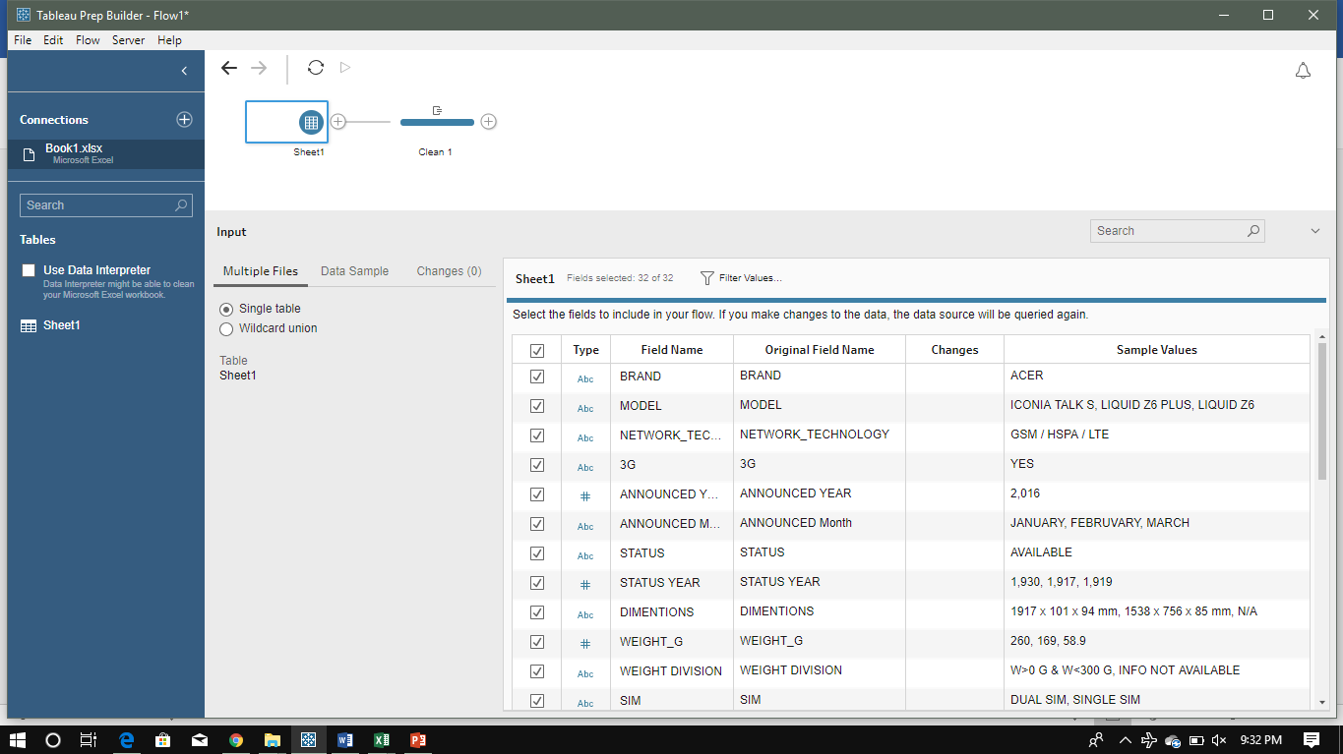

**Analysis-1**

**Introduction:**

Different companies of smartphones launched in India during different year.

**General Description:**

By analysing the data and showing how many different companies of smartphones launched in india.

**Specific Requirements:**

By placing brand in rows and sum of models in the columns we get the graph of showing different no of smartphones launched in different years.

**Analysis Results:**

By this analysis different companies of smartphones launched is extracted.

**Visualization:**

Showing the output with the help of horizontal bars.

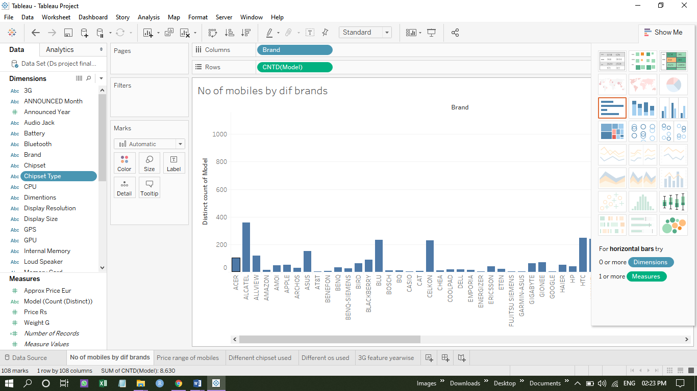

**Analysis-2**

**Introduction:**

Analysis on the price of smartphones

**General Description:**

By analysing the data and dividing the smartphones into different price ranges.

**Specific Requirements:**

By placing price vertical rows and brand in colums. Smartphones in the different price ranges will be analysed

**Analysis Results:**

By this analysis different smartphones were extracted in the given price range.

**Visualization:**

Showing the output with the help of packed bubbles.

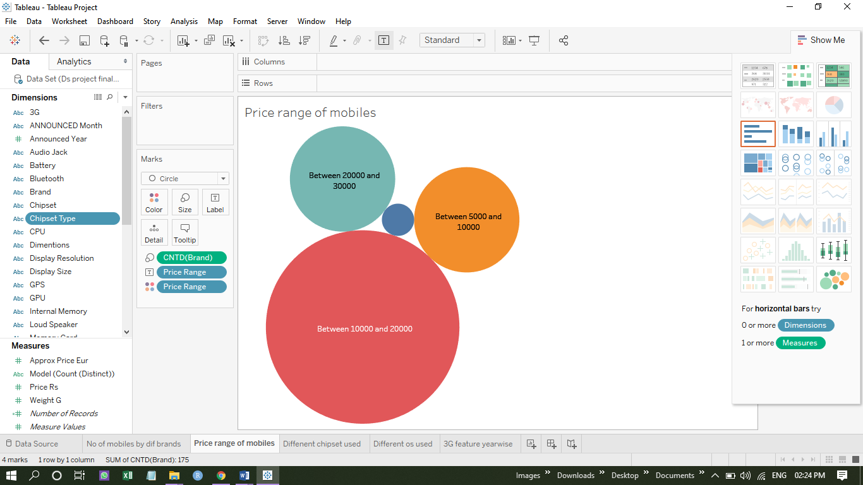

**Analysis-3**

**Introduction:**

Type of chipset used by various smartphones.

**General Description:**

Analysing the data and showing which type of chipset is used by the smartphones.

**Specific Requirements:**

By placing chipset in rows and count of models in columns different type of chipsets used by the smartphones can be found .

**Analysis Results:**

By this analysis smartphones with different chipsets is extracted.

**Visualization:**

Showing the output with the help of tree maps.

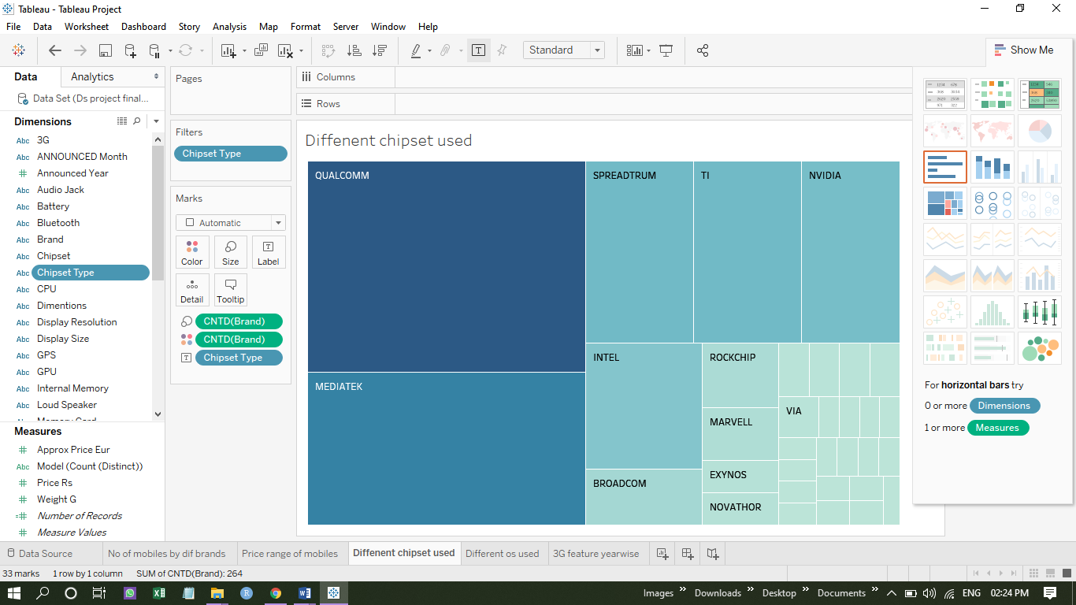

**Analysis-4**

**Introduction:**

Analysis on the os used in the various smartphones.

**General Description:**

Analysing the data and showing the battery type used in the smartphones.

**Specific Requirements:**

By placing os in rows and count of model in columns .different os used by the smartphones is found

**Analysis Results:**

By this analysis different battery types used in the smartphones is extracted.

**Visualization:**

Showing the output with the help of packed bubbles.

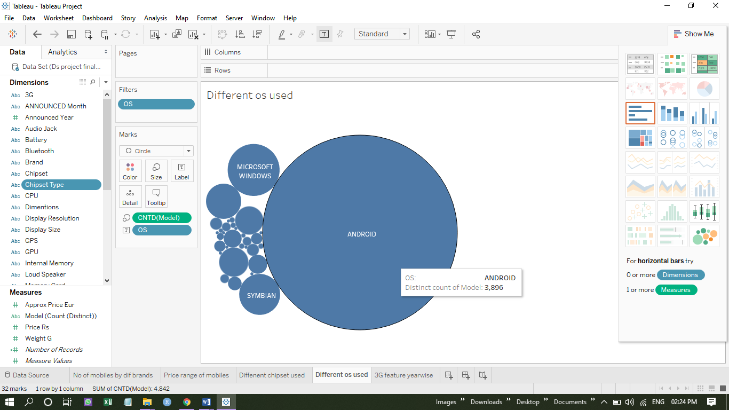

**Analysis-5**

**Introduction:**

No of smartphones supports 3g.

**General Description:**

Analysing the data and showing the devices which support 4g.

**Specific Requirements:**

By placing location and year in rows and 3G in the columns different smartphones supporting 3G can be found.

**Analysis Results:**

By this analysis different smartphones having 3g is extracted.

**Visualization:**

Showing the output with the help of lines.

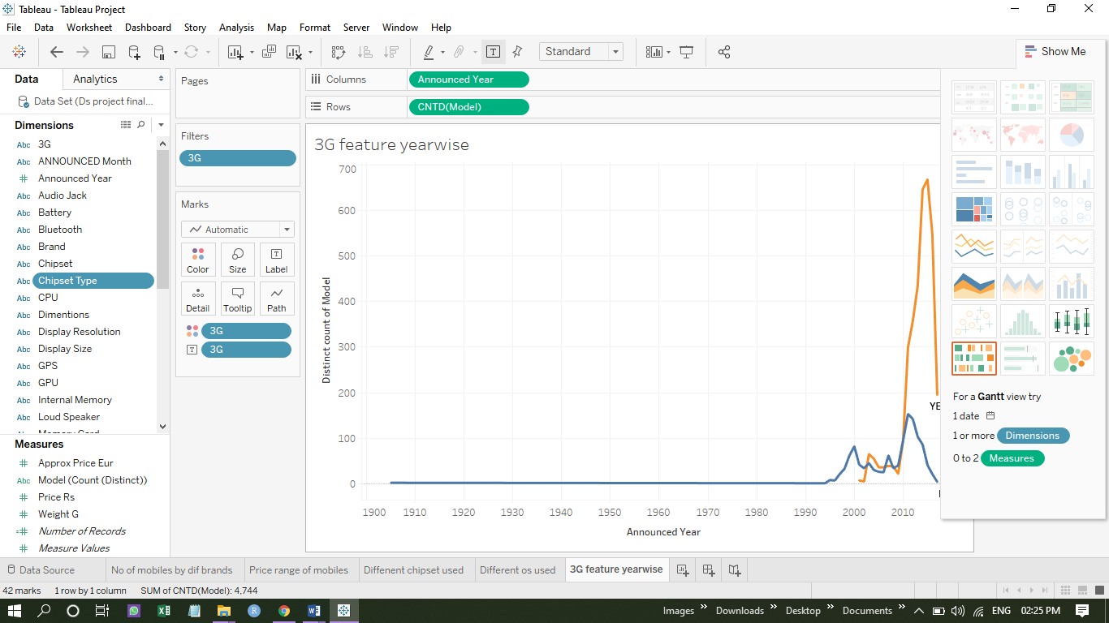

**REFERENCES**

1. Visited https://community.tableau.com to know how the operations done on tableau.

2. Referred MICROSOFT EXCEL 2016 BIBLE: THE COMPREHENSIVE TUTORIAL

RESOURCE book regarding to how to do pivoting and how to do visualization for the

particular dataset.

**BIBLIOGRAPHY**

1. Downloaded the Gsm Arena Mobile devices dataset from [www.kaggle.com](http://www.kaggle.com).

2. I have downloaded tableau from [www.tableau](http://www.tableau) prep for students.com for cleaning the data set